A1Wd Superimposing two sets of data onto one graph

In certain circumstances, we may wish to combine different data sets onto the same Excel graph.

Example

A market researcher has collected a set of data that measures the distance travelled by 8 sales men. The market researcher has calculated the average and standard deviation (concepts to be covered in the next chapter) and requires a graph of mileage travelled against ID and the two error measurements provided in Table 1.

ID | Mileage | Average + error | Average - error
1 | 220 | 239 | 208
2 | 210 | 239 | 208
3 | 230 | 239 | 208
4 | 200 | 239 | 208
5 | 250 | 239 | 208
6 | 238 | 239 | 208
7 | 219 | 239 | 208
8 | 220 | 239 | 208
Average = | 223.38
Standard deviation = | 15.74
Table 1

Excel solution

Step 1 Input data series

Highlight all three columns (including labels)
Mileage: Cells B4:B12
Average + error: Cells C4:C12
Average – error: Cells D4:D12
(include data labels)

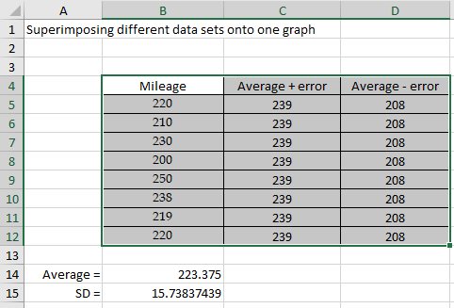
Figure 1

Step 2 Select Insert > Column > choose first option.

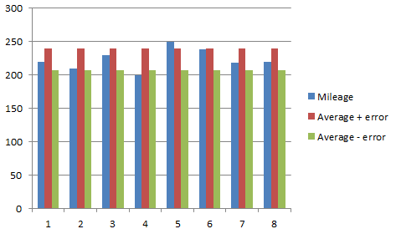
Figure 2

Step 3 Edit the chart

From Figure 2, we note that we have three bars per ID. Edit the chart to include a chart title, axes titles, and remove horizontal grid lines to give the chart illustrated in Figure 3.

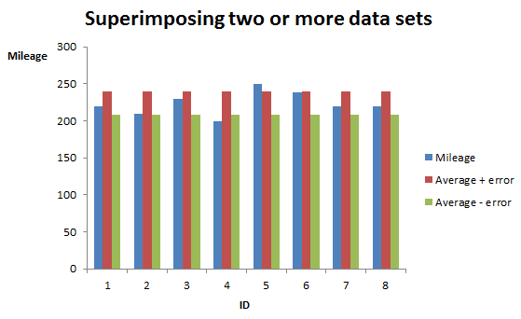
Figure 3

Step 4 Further modification of the chart by changing the bars representing the error term (average - error, average + error) to be horizontal dashed lines rather than vertical bars. Select average – error bar (this will select all the average – error bars for each ID). Right-click on average – error bar > Select Change Series Chart Type > Select Line and click OK. Repeat for average + error bars. The final chart is illustrated in Figure 4.

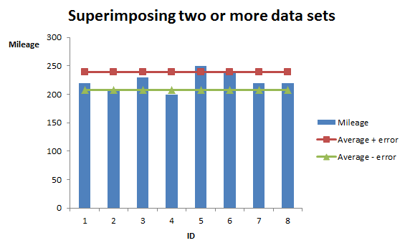
Figure 4

Check your understanding

X1 Table 2 represents the 2013-2015 quarterly sales for a new chocolate bar.

 | Year
Quarter | 2015 | 2016 | 2017
Q1 | 22000 | 24000 | 25000
Q2 | 25000 | 27000 | 27000
Q3 | 21000 | 22000 | 22000
Q4 | 28000 | 30000 | 31000
Table 2

(a) Create a bar chart to represent this data.
(b) Comment on how the sales change per quarter for each year.

